1) run Create Tables Script (CreateTables-Step1).

2) USE SQL Management studio , right click on database and click on Tasks->Import Data.

Choose source as excel and file path as path to file that we will get from infor.

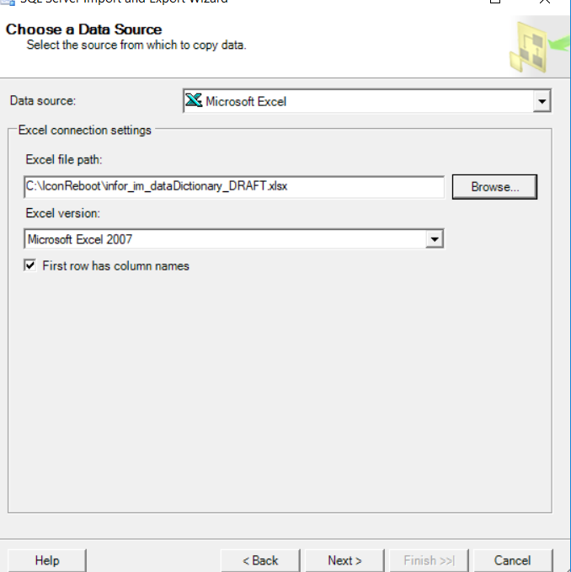

Then click on next

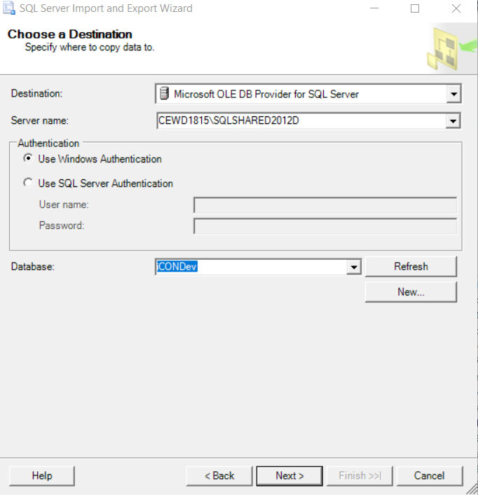

Enter server name and select database name (Icon). Then click on next button. Choose “Copy Data from one or more table or views”. Click on next button.

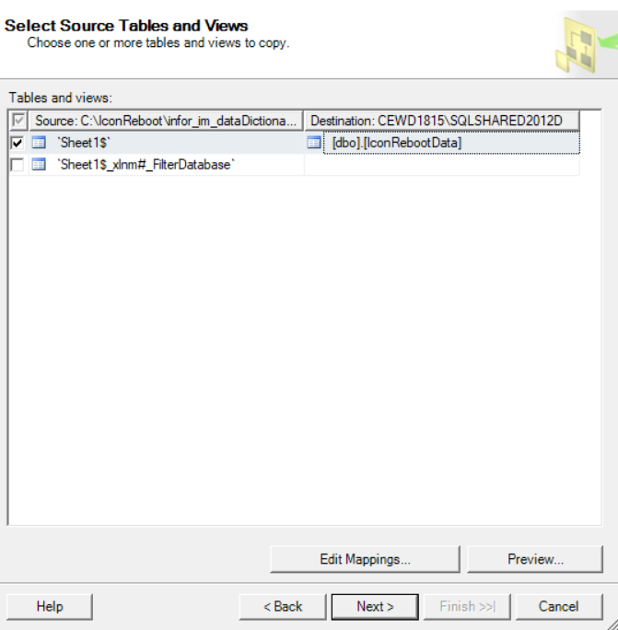

Choose source as Sheet1$ and destination as IconRebootData table. Click “Next” and then click “Finish” Button.

3) Run “DeleteAndReseedStaticTables-Step3” script to populate static data

4) Make sure ConvertData.exe.config file has right connection to icon database. Then Run ConvertData.exe.

5) Run FixTraitCodes-Step5 ” script to populate trait codes